Newsletter Bulletins | For your Team
Image | Heading | Body Paragraph | Link/CTA button
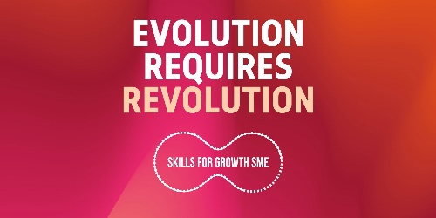 | We’ve joined the #SkillsRevolution! | We’re excited to announce that for the next 26 weeks we’ll be embarking on the Skills for Growth – SME Support programme, to help upskill employees where you may need it, and undergo some operational changes for the continued success of the business.  Commissioned by the Greater Manchester Combined Authority with funding from the European Social Fund, and delivered by GC Business Growth Hub in partnership with the Greater Manchester Chamber of Commerce, we are excited to introduce you to Skills for Growth - SME Support - a very special programme helping to empower our staff and open opportunities for our business in the future.  Watch this space for updates to come, and if you’d like to know more about the programme, click on the link below. | Learn More  Link to: https://skillsforgrowthsme.co.uk/?utm_source=DigitalKits&utm_medium=Newsletter&utm_campaign=Clients-Toolkit
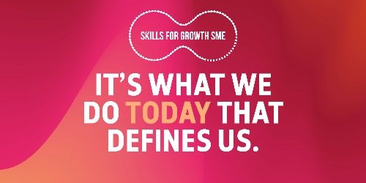 | See what we’ve been working on… | We’ve recently joined hands with Skills for Growth – SME Support to work on [LIST THE KEY GOALS THAT YOU ARE WORKING TOWARDS HERE EG. UPSKILLING EMPLOYEES, IMPLEMENTING A WELLBEING PLAN ETC].  To empower our employees and open new opportunities for our business in the future, we’re proud to say we’re officially becoming ‘skills revolutionaries’!  If knowledge really is power, we’re getting stronger by the day. | Learn more  Link to: https://skillsforgrowthsme.co.uk/?utm_source=DigitalKits&utm_medium=Newsletter&utm_campaign=Clients-Toolkit
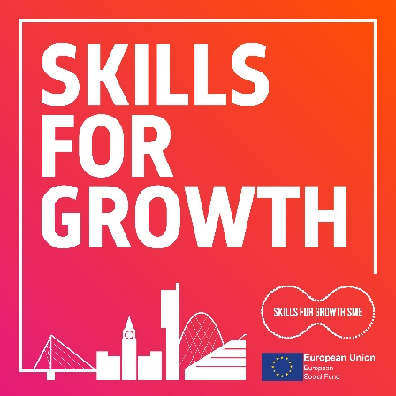 | Listen to ‘Skills For Growth’ the Podcast | Skills For Growth is the podcast for businesses in Greater Manchester.  In each episode, host Andy Hall speaks to industry insiders and the people on the ground creating the opportunities of the future, to find out exactly how you can put yourself and your business in the best position to ensure growth, financial resilience and a happy and healthy workforce.  Listen and subscribe on all your favourite podcast apps. | Listen Now  Link to: https://skillsforgrowthsme.co.uk/more/skills-for-growth-podcast/?utm_source=Digital+Kits&utm_medium=Newsletter&utm_campaign=Clients-Toolkit
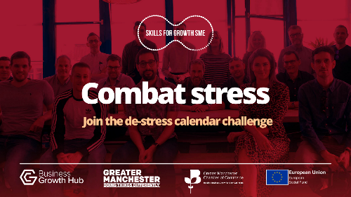 | Join the de-stress calendar challenge | Are you feeling burnt out?  We’re joining Skills for Growth -SME Support to invite you to combat stress and take part in the de-stress calendar challenge.  Work with your line manager and colleagues to nurture healthy habits in relation to your physical, mental, environmental, emotional and workplace wellbeing.  If you’re ready to join the challenge, click the button below to download the calendar. | Join Now  Link to: https://www.skillsforgrowthsme.co.uk/de-stress-calendar-challenge/?utm_source=DigitalKits&utm_medium=Newsletter&utm_campaign=Clients-Toolkit
 | Growing our team with Apprenticeships | We’re growing our team through Apprenticeships with the help of Skills for Growth – SME Support!  Congratulations to:  - Please bullet point your apprentices and their apprenticeship type here, who you employed/upskilled with support from our Apprenticeship Specialist  Learning at work is empowering for individuals, great for career progression and essential to our future as a business. If you feel there’s room for you to grow and would like to explore apprenticeships for your own career here, talk to your line manager about your options. | Learn more  Link to: https://www.skillsforgrowthsme.co.uk/specialist-services/apprenticeship-specialist/?utm_source=DigitalKits&utm_medium=Newsletter&utm_campaign=Clients-Toolkit
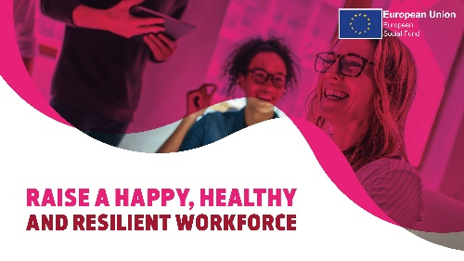 | Protecting your health at work | We’ve joined Skills for Growth – SME Support to embed wellness into our company culture.  - Please bullet point the outcomes you are working towards with our Health & Wellbeing Specialists here  We wouldn’t be here without our team! So, we’re doing our best to raise a happy, healthy and resilient culture for your wellbeing. Click the button below to find out more about Health & Wellbeing with Skills for Growth – SME Support, and if you’d like to talk more about workplace wellbeing, talk to your line manager today. | Learn more  Link to: https://www.skillsforgrowthsme.co.uk/specialist-services/wellbeing-specialist/?utm_source=DigitalKits&utm_medium=Newsletter&utm_campaign=Clients-Toolkit
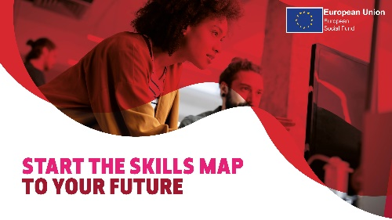 | GM Skills Map | Line Managers, have you checked out GM Skills Map yet? It’s an online portal and learning management system we’re using to help bridge our skills gaps and empower our staff.  GM Skills Map gives us the opportunity to explore fully funded, part funded and commercial training for employees, or vice versa – for employees to explore training and come to their line manager with suggestions about skills developments that will help them develop within our company.  If you haven’t had a look yet, we encourage you all to explore GM Skills Map and reflect on yours and your team’s skills gaps. Here at [Company Name] we’re working towards inclusive growth, and that means investing in the business and the people within in. | Take a look  Link to: https://gmskillsmap.co.uk/?utm_source=DigitalKits&utm_medium=Newsletter&utm_campaign=Clients-Toolkit

